
STANDARD OPERATING PROCEDURES
MANUAL TOOLROOM LATHES

TABLE OF CONTENTS
SECTION | TOPIC(S) | PAGE
 | Basic Capabilities | 2
 | Basic Machine Parts | 3 & 4
 | Manual Lathe Safety Rules | 5
1 | Using The Machine | 6
2 | Common lathe cutting tools | 6
3 | Using a lathe chuck | 8
4 | Tool post and cutting tool set-up | 9
5 | Carriage and cross feed | 9
6 | Compound slide | 10
7 | Tailstock and it’s features | 10
8 | Setting workpiece length | 10
9 | Taking cuts on the lathe | 11
10 | Calculating speeds & feed | 12
11 | Cutting fluids | 12
12 | Cleaning the machine | 13
13 | Unfinished work | 13
14 | Other considerations | 13

BASIC CAPABILITIES
Lathes are very versatile. They are usually used to machine (turn) round (cylindrical) parts, but can also produce many unique and irregular shapes. A lathe can drill, ream, turn, knurl, cut and shape cylindrical parts, Although there are several other types of LATHES, this document will focus only on the manual lathe. They are also known as tool room lathes and/or engine lathes.
Normally, a part is held in a collet or lathe chuck and a cutting tool is held in a tool post. The lathe is switched on and the part begins to rotate. The cutting tool is then brought to the rotating part and removes material.

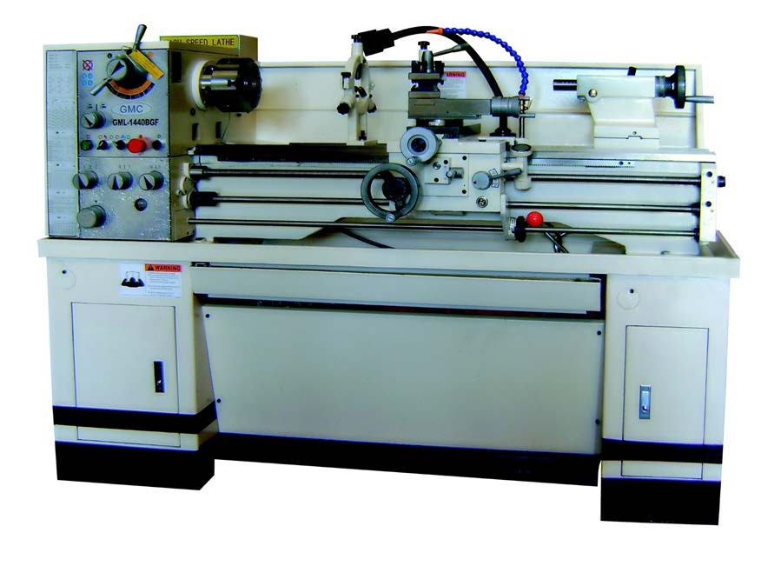

The goal of this SOP and the accompanying “training” is not to make you a lathe operator/machinist, but to make sure you can safely do certain tasks. It applies to all students, staff, faculty and others who wish to use the machine shop! This SOP should be read, fully understood, and reviewed at the machine with the Shop Manager. Every machine user will have to take the “Basic User Safety Test”, demonstrate “hands-on” proficiency and then sign the “BASIC USER CLEARANCE FORM & SUPERVISED EXPERIENCE LOG” before being approved to operate the machine. The allowable machining tasks will be limited to those covered in this SOP.

There is much more to using a lathe than what is covered in this SOP. Always ask before doing a new operation!

BASIC MACHINE PARTS

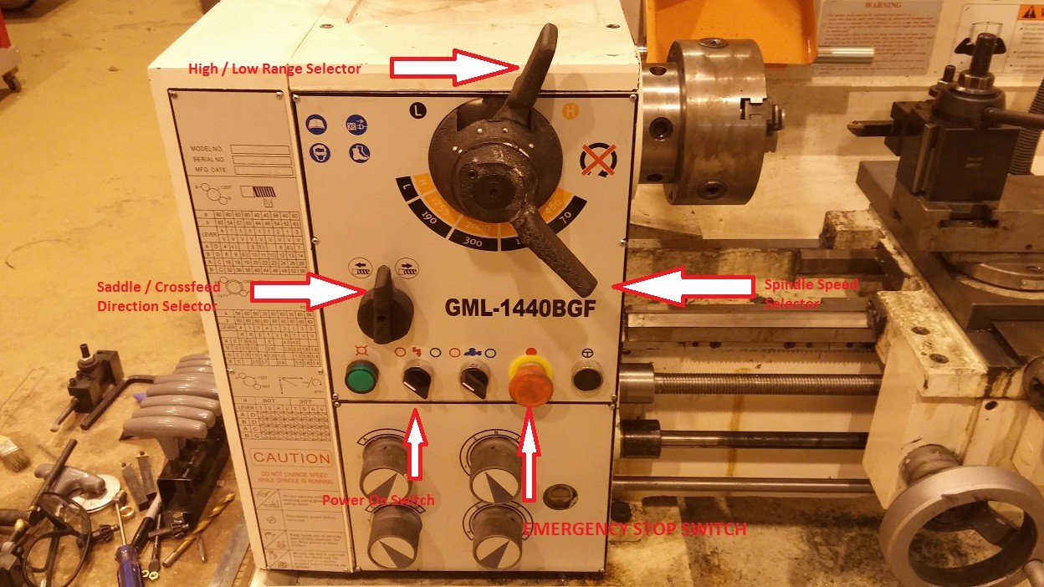

High / Low Range Selector: Use to change High / Low range of Spindle Speed Selector.
Spindle Speed Selector: Used in conjunction with Hi/Lo Range to change RPM of 3-Jaw Chuck.

Saddle / Cross feed
Direction Selector: Used for selection of either the saddle or the cross feed direction.
NEVER CHANGE GEARS OR DIRECTIONS WITH LATHE UNDER ROTATION. IT WILL BREAK THE MACHINE.

Power On Switch: Applies power to operate lathe.

Emergency Stop Switch: KNOW WHERE THIS IS! Used to turn off power to lathe.

Continued…

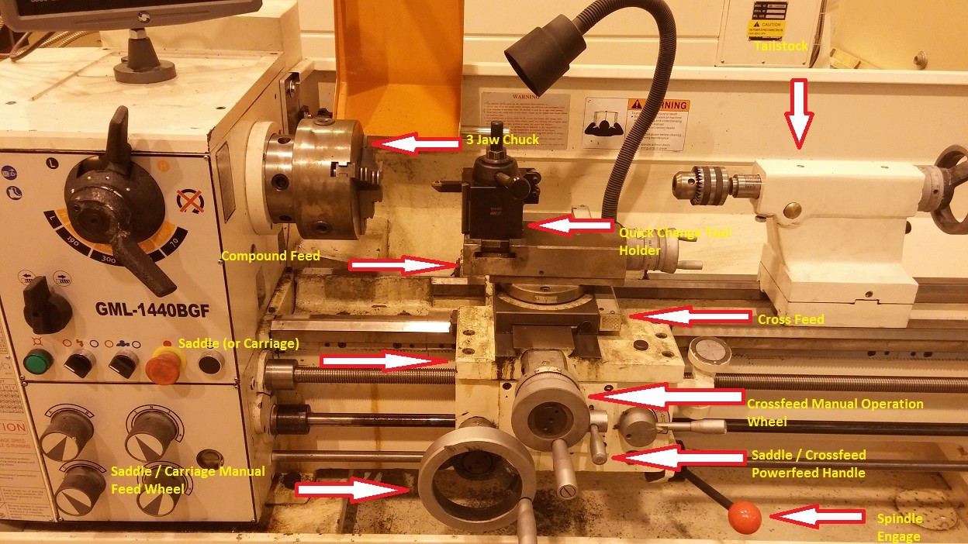

3-Jaw Chuck: Used to hold work (material) to be machined.
Compound Feed: For manually feeding cutting tools at an angle to the spindle. Saddle (or Carriage): Carries the tool holder and cross feed in A “Y” direction.
Saddle / Carriage Manual
Feed Wheel: Moves the saddle in the “Y” direction. Used for diameter reduction operations. Quick Change Tool Holder: Holds the cutting tools for machine operations.
Cross Feed:  Cross Feed Manual | Carries the cross feed, compound feed and tool holder in an “X” direction.
Operation Wheel:  Saddle / Cross Feed | Used to move cross feed in “X” direction. Most used for facing or length reduction.
Power Feed Handle: | Depending on position of saddle / cross feed direction selector, can automatically
 | move either the saddle or cross feed in their respective directions.
Spindle Engage Handle: | Start the spindle and work rotating. Can also turn spindle / chuck forward
 | Forward or backward. NEVER SWITCH DIRECTIONS WITHOUT SPINDLE ROTATION
 | COMPLETLEY STOPPED.
Tailstock: | Holds drill chuck, live center (for machining between centers), or dead center.

MANUAL LATHE SAFETY RULES

For everyone using the manual lathe, without exceptions!
- Never wear long sleeves, gloves or any jewelry and always tie your hair back.
- Keep ALL rags away from the machine while it is in motion.
- Never use the lathe when tired or rushed for time!
- ALWAYS remove the chuck key from chuck immediately after using!
- Make sure that the chuck or faceplate is ALWAYS fully tightened onto the spindle.
- Make sure your part is securely tightened in the chuck or collet.
- Always check that the chuck or collet will clear the tool post before you start.
- Move the tool bit, tool post and/or tailstock a safe distance from the chuck or collet when inserting or removing your workpiece.
- Don’t run the machine faster than the proper cutting speed.
- In setting up the tool holder, place it to the left side of the compound slide to prevent the compound slide from running into the chuck or spindle attachments.
- Always clamp the tool bit as short as possible in the tool holder to prevent it from breaking or chattering.
- Always make sure that the tool bit is sharp, at the correct height and has the proper clearance.
- Filing on work revolving in the lathe is only done with permission and supervision!
- If work is turned between centers, make sure that the proper adjustments are made between centers and that the tailstock is locked in place.
- Do not grasp or touch chips or turnings with your fingers. It is safer to turn off the lathe before clearing chips with a brush or soft air blasts.
- Set the tool bit on the centerline of work to prevent work from climbing over tool or cutting above center and dragging.
- Don’t cut work completely through when turning between centers.
- Turn chuck or face plate through by hand before turning on the power to be sure there is no binding or clearance problems.
- Stop the machine before taking ANY measurements.
- Students are NOT ALLOWED to teach other students in the use of the lathe!
- Leave the entire machine CLEANER than when you found it!

Be safe, ask if unsure, use your common sense, and look out for the safety of others.

USING THE MACHINE

1. Three important elements.

In order to get an efficient process, good surface finish and correct geometry on the lathe, it is important to adjust the rotating speed (RPM), a cutting depth and a feed speed. Please note that these important elements cannot be decided easily, because these suitable values are quite different for each material.
- ROTATION SPEED Is the number of rotations per minute (rpm) of the chuck or collet. When the rotating speed is high, higher removal rates are possible. But when too high, too much friction could be generated. However, since a little operation mistakes may lead to the serious accident, it is better to set lower rotating speed at the first stage.
- CUTTING DEPTH The cutting depth of the tool affects to the processing speed and the roughness of surface. When the cutting depth is big, the processing speed becomes quick, but the surface temperature becomes high, and it has rough surface. Taking off too much material can break the tool or your workpiece. If you do not know a suitable cutting depth, it is better to set to small value. Always remove a very small amount of material on your final pass to assure a good surface finish.
- FEED SPEED The feed speed of the tool also affects to the processing speed and the roughness of surface.
When the feed is high, you can remove a lot of material quickly. When the feed is low, the surface improves.
There are automatic feeds on these machines that can move the feed handles for you at a very accurate feed. These auto feeds maintain a consultant speed and result in nicer finishes. A beginner must always use the manual mode, until they have enough experience. A user should hold the handle of the automatic feed until the operation is complete and never walk away. Serious accidents may occur if the tool bit or any part of the post or the cross slides touch the collet or chuck!
- Common lathe cutting tools.

Always use the correct and properly sharpened tool for the job. Dull tools lead to bad surface finishes, out of tolerance parts and potentially a hazard situation. Below are the three most common types of lathe tools.

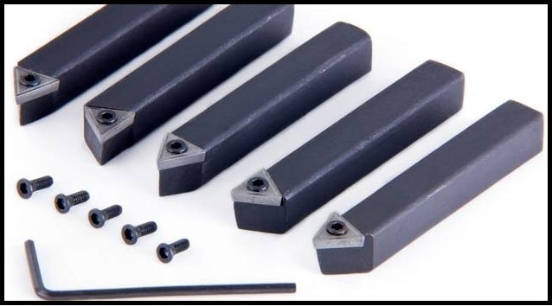
Figure 1 - Lathe Bit
  - THE LATHE BIT The image above shows the most common lathe cutting tools, they are called lathe bits. These can cut outside surfaces and edges. There are versions that consist of a piece of carbide brazed onto a rectangular steel bar. The ones in the above image are called “insert lathe tools.” It is because they have a carbide insert that can be replaced or rotated when they become dull. This is ideal for those that have little or no experience in grinding their own tools.

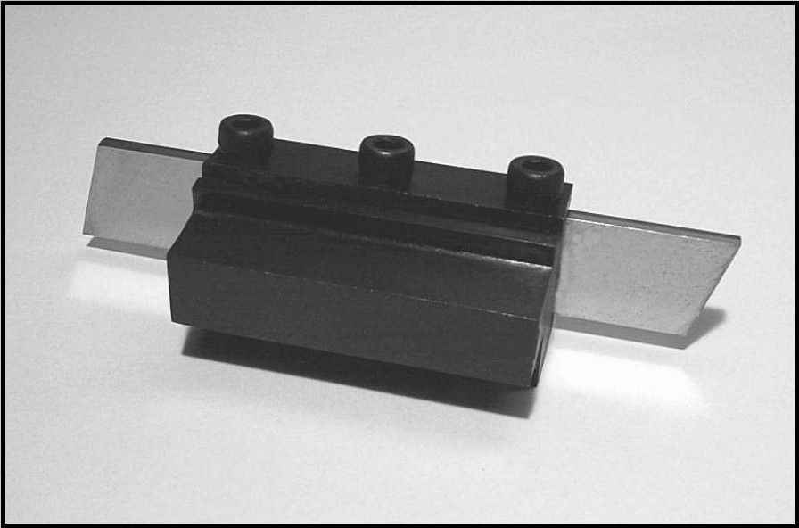
Figure 2 - Cut Off Tool

  - THE CUT OFF TOOL This tool (shown above) is also called a “parting tool.” It is primarily used for cutting off (aka, parting) the workpiece and making outside grooves. This tool can only cut “across” the part in one direction (along the X axis).

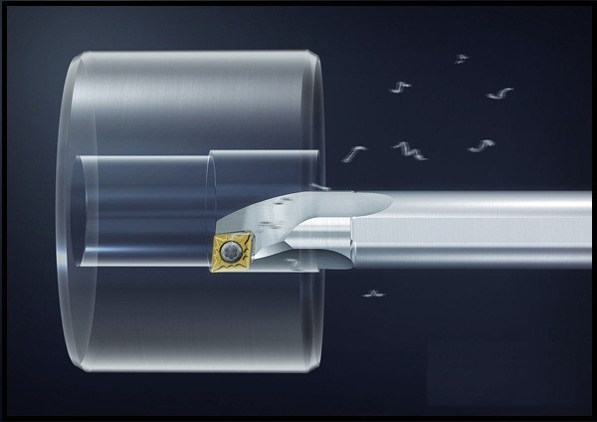
Figure 3 - Boring Bar

  - THE BORING BAR This tool (shown above) is mainly used to make diametrical (round) holes of any size and depth. Normally used to cut at an inside surface. It can make a hole that is much bigger and more accurate than a regular drill. The other big advantage is that a boring bar can make irregular diameter holes with flat bottoms. Drills and reamers are only available in “standard” sizes, but a boring bar does not have that limitation. In most cases, there needs to be an existing hole to fit the boring bar. This hole can be produced with the use of a regular drill bit.
- Clamping work-pieces using a Lathe Chuck.

A chuck is directly attached to the drive mechanism (spindle) of the lathe and rotates at variable speeds up to as much as 2000 rpm on this machine. A 3 or 6 jaw chuck has the ability to hold a wide range of cylindrical parts from .250” diameter, all the way up to 8” diameter.

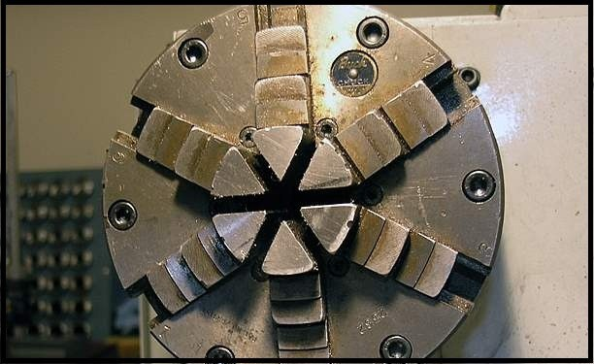

To start, the operator clamps the piece of metal to be turned in the chuck. Depending on the size (diameter and/or length) of the part, will determine how much of it will need to be clamped in the chuck. These chucks are very accurate, but pieces of metal are not always perfectly straight and level. So it is recommended that you use a dial indicator to check the concentricity your workpiece in relationship to the machine. This can be done by placing the indicator on top of the tool post with the dial stem touching the part and with the machine turned OFF, rotating the chuck by hand. Depending on the required precision, it is important to check the trueness of the part to within one or two thousands of an inch.
Once you are sure that the part is true, tighten the chuck as tight as necessary to hold the part without damaging the clamping surface. This is done by placing the "chuck key" in the key receptacle on the side of the chuck and turning it clockwise. NEVER LEAVE THE KEY IN THE CHUCK!!! Place the chuck key on the workbench, away from all
moving parts. If the key is left in and the machine started, serious bodily harm will result! Check once more for “true” if the precision is necessary. Before even starting the machine, spin the chuck by hand to make sure it clears the carriage, cross slide, tools, tool post and/or all other parts of the machine!
There are also 4 jaw chucks where each jaw can be adjusted independently, these are for off-center lathe work and require special training. Consult the shop supervisor if your parts need this tool.
The spinning jaws on a chuck are very dangerous. At certain speeds, the jaws become an invisible blur! In a noisy environment, a spinning chuck may not appear to be spinning. Always be aware of the jaws as you are working on the lathe! Keep your hands, body and cutting tools well away from the chuck at all times!

4. Tool post and cutting tool set-up.

The tool post is where the cutting tool and holder will be located. The tool post uses a dovetail design to enable a user to pre-set a number of tools for easy and accurate changes between cutting tools. The tool post is permanently mounted to the machine, but can be move and rotated. The tool holders have knob on top to quickly adjust cutting tool heights.

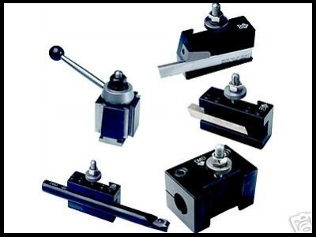

For safe and efficient cutting, the tip of the tool must be located directly on the center of the part in the chuck! Too high and the base of the tool will push on the part. This may damage your workpiece or break the cutting tool. If the tool is set too low, the tip of the tool will tend to gouge and/or cut too deep. It will also leave an undesirable “nub” when you reach the center of the workpiece.
A quick trick for setting the tool height is to gently squeeze a 6” metal scale between the cutting tool and your workpiece with the machine OFF and spindle stopped. Have the shop supervisor show you how to do this properly and easily. This technique will get you very close to the ideal tool cutting height with most lathe tools.
- Moving the carriage and cross slide.

The carriage moves along the “ways” toward and away from the chuck (the Z axis). The cross slide moves toward and away from the center or the part (the X axis). The carriage and the cross slide are both moved manually by using hand wheels. The cross slide hand wheel has dials that show DIAMETRICAL distances. Each graduation on the hand wheel indicates .001”of diameter movement of your tool. Movement of the carriage is measure with the use of a dial indicator mounted on the left side of the carriage. It is limited to 2 inches of travel for measurement purposes, but can be set anywhere along the carriage’s travels.

In addition, there is a lever on the carriage that turns on the carriage and cross feed “power feeds.” One feeds (moves) the carriage at a predetermined speed and the other feeds the cross-slide. There is also a (push/pull) knob that changes the direction of both feed levers! To understand these features, you should test these operations well away from the chuck, at different speeds and while supervised. This will enable you to get the feel of the automated movements of the machine.

- Compound slide

A compound slide is a smaller version of the cross feed with one major difference, it can be set at any angle. It offers a way to turn tapers and cut angles on a lathe. Most commonly it is used to cut tapered holes and other conical shapes using a boring bar or lathe bits. There is a degree wheel directly underneath the compound slide that can be set to the specific angle that is needed. There is no “power feed” option and it must be operated manually.

- Tailstock and its features.

The tailstock is located on the opposite end of the lathe from the chuck. It is mounted on the ways of the machine and shares a centerline with the chuck. The tail-stock’s most common use is to drill out the centers of work pieces. Into the tailstock you can insert a drill chuck (that has a compatible “Jacobs Taper”). The tailstock is slid toward the workpiece and LOCKED DOWN, leaving about 1” of room between the drill and the workpiece. The tailstock hand wheel is then used to feed the drill into the workpiece. Unlike other machines, the lathe workpiece spins and the cutting tool stays still.

The other common use is to support long work pieces (shafts / tubes / rods) with the use of a live center. A live center is a cone shaped object with a Jacobs’s taper adapter that is inserted into the tailstock (like a drill chuck). The cone portion spins on an internal ball bearing mechanism. This is used to fit into a center hole of the work piece to hold it firmly between the tailstock and chuck. It is VERY important to lock down the tailstock and set correct tension with the tailstock hand wheel whenever using the live center. This is done for pieces that are too long to be safely held in just a chuck or collet. Normally, if the length of piece is sticking out more than 5 times the diameter, a live center should be used. For example, if the part is 1” in diameter, it should not stick out more than 5” in length. Again, check with the shop supervisor for guidance! Live centers should not be used when the workpiece will be parted with a cut-off tool.

- Setting workpiece length.

Finding the end of a cylindrical part sometimes requires actually touching the rotating part with the tool bit. Having checked that there are no chances of collision, and with the part rotating at a moderate speed. Very slowly ease the tool (along the z-axis, using the carriage hand wheel) toward the end of the part until it just touches. There will be very fine shavings on the cutting edge of the tool. Now use the cross feed hand wheel (along the Y-axis) to move the cutting tool toward you and away from the part. Without removing the tool from its position, set the indicator marks on the dial to the zero mark. You may also choose to “clean up” the face of the part, by moving in a few thousandths (.001” to .010”) and moving the tool across the face of the part to the center of the diameter. Remember to reset zero (on the DRO indicator) after cleaning a face. Always ask for help when attempting any of these procedures for the first time.

- Taking cuts on the lathe.

Always start with a lower speed of chuck rotation and take shallow cuts until slowly increasing the rpm's until the tool cuts smoothly and does not appear to heat up. This can be seen by (steel) chips discoloring to a blue tint, or when the cutting fluid starts to burn off in a visible vapor. Nice, smooth chips are ideal. If you get a long stringy cut instead of a chip, increase feed until material comes off in chips. The depth of the cut is regulated by the cross slide handle. Keep the ways and carriage clear of chips, and do not use your hands use a small brush. The chips can be very hot and are extremely sharp and can cause harm. The machine should be cutting quietly and there should be no shuddering or vibration. Until you get use to the operation of the piece of machinery test at various speeds and feeds (see below).
When cutting steels too aggressively, it can heat up quickly. This heat can damage both the part and the cutting tool. Use the correct cutting fluid for the job (see below). This will extend the life of the tool and keep the part from “work hardening” because of over-heating.
Plastics cut very easily on the lathe and normally don’t require a cutting fluid. The critical points to plastics is to not go too fast (may melt) and make sure your tools are very sharp!

- Calculating Speeds and Feeds “A happy machine is a quiet machine!”

“Speed” refers to the spindle (chuck) RPM (Revolutions per Minute). “Feed or feedrate” refers to the amount you make the cutting tool move across or into your workpiece. Feeds and speeds affect the time to finish a cut, tool life, finish of the machined surface and power required of the machine. The cutting speed is mostly determined by the material to be cut and the material of the cutter. Lubricant plays a critical role in cutting. Make sure you use plenty of the correct type! Broken or abused tools are the responsibility of the user!
To find the right speed for any task, first ask a shop supervisor. If unavailable, use the “Speed vs. Feed” guidelines as a starting point. The feed rate depends on the width and depth of cut, finish desired and many other variables. THE most common mistake is to run the feeds or spindle speed too fast!

SPEED VS. FEED - BASIC GUIDELINES

IF | THEN
You INCREASE the FEEDRATE too much: | You risk taking too big a “bite” and will break the cutter. You
DECREASE the FEEDRATE too much: | You risk “rubbing” (not cutting) and will wear out the cutter.
You INCREASE the SPINDLE SPEED too much: | You will not cut, but instead burn up the tool with friction.
You DECREASE the SPINDLE SPEED too much: | Your cut will be very slow.
You find the right balance: | The machine will be quiet (not screaming or shaking)
You find the right balance: | You will be making (nice, not discolored) chips.
You find the right balance: | You will be removing material and the cutter will last!

- Cutting Fluids and their applications.

Different applications and/or materials require slightly different cutting fluids. These fluids are designed to provide the correct amount of lubrication, cooling, better surface finish, increased tool life and more. All cutting fluids (especially WS11) should be thoroughly cleaned / removed from the machine when finished! The machine should be dry and a light “misting” of WD40 applied to the entire vice, tables and machine ways to prevent corrosion.
• Fluids o WS11 – Water soluble oil. A combination of 5% WS11 oil + 95% water. Resembles “milk” o A9 Cutting Fluid. Specially designed for aluminum and other soft metals. Green in color. o MolyDee. A thick, black, heavy cutting fluid for steels and other tough to machine materials.
  - WD40. Not a cutting fluid, only use to protect for corrosion on cleaned machines.
• Applications: o Aluminum & other soft materials tapping: Use A9 cutting fluid. Applied with a drip from the nozzle or brushed onto the tap.
  - Aluminum & other soft materials drilling/milling/boring/etc.: Apply liberal amounts of WS11 with an acid brush or spray bottle.
  - Steel tapping & heavy cutting: Use MolyDee, applied with a drip or acid brush directly to the tap. o Steel drilling/milling/boring/etc.: Apply liberal amounts of WS11 with an acid brush or spray bottle. o Plastics: Most do not need any cutting fluids. Correct speeds & feeds are more critical.

- Cleaning the Machine proper procedures for care and feeding

The entire machine must be cleaned after every use. If another user needs the machine, immediately after you, make sure you discuss who will leave the machine clean. The process is simple and should not take more than 10 minutes. Make sure you are aware of clock to leave enough time to finish clean-up. The procedure is:
  - Turn off the machine and remove the tool holder. Brush, vacuum or wipe it clean.
  - Put away all your hand, set-up and cutting tools. If not sure where they go, ask a supervisor.
  - Use a brush or shop - vac to remove the chips from the vice, table and ways.
  - Do not use compressed air – The possibility of metal chips getting in eyes is GREATLY increased.
  - Brush or vacuum the difficult to reach spots. Wipe the spindle, slides, ways, tool post, chuck, etc.…
  - Wipe off ALL cutting fluids and oils from the ENTIRE machine. Top to bottom, machine must be dry.
  - Gently mist the slides, ways, chuck(s) with WD40. Move the carriage and slides to mist all surfaces.
  - Sweep the floor and surrounding areas. Chips are to be placed in chip buckets, not regular trash cans.
  - There should be NO visible chips of any size on the machine. Leave it cleaner than when you found it.

- Unfinished Work and leaving your machine.

A machine may be left set-up with your job ONLY if you will be returning at the next available opportunity. If it is less than a 2 hour gap, the machine may be left as is, just sweep the floor. If it is to be more than two hours or you are unsure, the machine must be cleaned (as above) and all tools/cutters/supplies must be put away. Machine set-ups will be broken down after 4 hours or if there is an urgent need, unless other arrangements are made with a supervisor or shop manager. Make sure you leave a sign with your name, phone number and a time/date when you will be returning to use the machine.

14. OTHER CONSIDERATIONS to be aware of:
- Never be afraid to ask for help and guidance, that is why the shop supervisor is there! When in doubt, always ask!
- These are very capable machines, but must be used correctly to avoid damage and accidents. Learn how to use them correctly; there are no shortcuts in quality and safety!
- Come prepared. Have your material/parts, complete (accurate) drawing(s), a plan of action and list of tools you will need.
- Cutting tools are VERY expensive and easy to break or dull. You are responsible if they are broken or damaged.
- Don’t leave rags, measuring or other precision tools on the machine. They will get damaged, contaminated or fall off.
- Double check your set-up before starting any operation. Check for tightness/rigidity, correct speeds/feeds, obstructions, tool post locked, etc.
- Re-read the safety rules, your life and health depends on it!

